Vocallabs.ai Product Teardown

From AI Voice-Agent Platform to Proof-Led Autonomous Resolution Engine
Prepared for: Product Intern Assignment
Company chosen: Vocallabs.ai
Submission focus: 5 sharp feedbacks across GTM & ICPs, Competitor Analysis, Features / Services, UX, and Potential Collaborations
Document type: Markdown teardown + execution plan
Version: v1.0
Date: 31 May 2026

0. Executive Summary
Vocallabs has the ingredients of a strong AI voice-agent company: voice agents for support, sales and booking, call-flow customization, workflow automation assets, hybrid AI-to-human handoff, voice analytics, India-first positioning, and a conversation-data flywheel.
The biggest PM opportunity is not simply to add more features. It is to make the product easier to trust, try, measure, and improve.

Core thesis
Vocallabs should not compete as “another AI voice-agent builder.” It should compete as the proof-led autonomous resolution engine for Indian business calls.
The market already has many platforms that can create AI voice agents. The harder and more valuable problem is proving that those agents can resolve messy real-world customer calls: noisy audio, Hinglish, interruptions, emotional callers, multi-intent requests, CRM actions, refunds, delivery issues, appointment changes, and live-agent handoff.

Product loop to build
Public demos → buyer trust → better pilots → pilot call data → Wild Calls Dataset → VVRB/EARP benchmark → roadmap priorities → product improvement → stronger public proof.

First-month PM wedge
The fastest win is the public product surface: website, demo library, vertical outcome pages, ROI calculator, pilot scorecard, and public learning channel.
This is low-hanging fruit because it does not require a massive model or infrastructure rebuild. It requires strong PM/GTM alignment and clear product storytelling.

Long-term moat
Use demos and pilot calls to build a future-proof benchmark:
- EARP: End-to-End Autonomous Resolution Parity
- VVRB: Vocallabs Voice Resolution Benchmark
- Wild Calls Dataset: real + synthetic + red-team + future-interaction calls
The benchmark should be hard enough that improving score directly improves product quality.

1. How I Approached This Teardown
I reviewed the assignment brief, the public website/blog surface, API documentation, open-source/developer assets, and visible competitor positioning.

Evaluation lens
I used the assignment’s expected structure:
- Observed: what I actually saw in the website/product surface/flow
- Problem: why it matters for the user or business
- Ship instead: specific actionable solution

Product pillars covered
Pillar | Feedback
GTM & ICPs | Move from generic AI voice-agent messaging to vertical outcome pages
Competitor Analysis | Build a public proof layer through a demo library
Features / Services | Convert call analytics into resolution and ROI scorecards
UX | Reduce time-to-proof from demo-request friction to instant product experience
Potential Collaborations | Turn SDK, n8n, Chrome extension, and open-source assets into a visible ecosystem

Prioritisation framework
I used a simple PM prioritisation lens combining Opportunity Solution Tree + RICE:
Criteria | Meaning in this teardown
Reach | How many visitors/pilots/customers this affects
Impact | Effect on trust, conversion, pilot success, and roadmap clarity
Confidence | How strongly public observations support this
Effort | Whether it can ship in the first month or requires deeper engineering

2. Context: What Vocallabs Is Already Signalling
The assignment describes Vocallabs as an AI voice-agent product for automating business calls with human-like fluency.

Existing product capabilities from the assignment
Capability | PM interpretation
AI voice agents for sales, support, and booking | Broad horizontal product surface
Intelligent call-flow builder | Customizable automation engine
SDK, n8n node, Chrome extension | Developer/operator workflow extensibility
Hybrid AI ↔ live-agent transition | Critical trust and safety capability
Voice analytics: emotion, intent, tone | Potential customer insight and QA layer

Existing moats from the assignment
Moat | PM interpretation
Full-stack ownership | Can connect design, execution, and analytics into one operating loop
India-first tuning | Strong differentiation if proven with Indian languages, accents, workflows, and noisy calls
Founder conviction | Speed and focus advantage
Proprietary conversation intelligence | Can become a data flywheel if converted into benchmark + roadmap process

Strategic interpretation
Vocallabs’ moat becomes stronger when the company can prove:
- The agent does not just talk; it resolves.
- It works in India-specific messy environments.
- It can safely hand off to humans when needed.
- Every pilot can show measurable business impact.
- Every failed call improves the dataset and roadmap.

3. One-Line Product Thesis
Make Vocallabs demo-first, outcome-first, and benchmark-backed.
This means:
- Demo-first: buyers can hear and inspect real use-case demos without waiting for a sales call.
- Outcome-first: every page sells business outcomes, not generic AI capabilities.
- Benchmark-backed: public demos, pilots, dashboards, and engineering evals use the same resolution framework.

4. Prioritised Feedback Summary
Priority | Feedback | Pillar | Why now
P0 | Build vertical outcome pages | GTM & ICPs | Clarifies who Vocallabs is for and what outcomes it drives
P0 | Launch public demo library | Competitor Analysis | Competitors make proof easier to experience
P0 | Redesign homepage for time-to-proof | UX | Buyers need to hear, try, and understand the product quickly
P1 | Add pilot scorecard + customer outcomes dashboard | Features / Services | Converts analytics into measurable business value
P1 | Launch integration + partner proof hub | Potential Collaborations | Makes ecosystem assets visible and usable
P1/P2 | Start VVRB + Wild Calls Dataset | Strategic layer | Converts demos/pilots into product-quality moat

Feedback 1 — GTM & ICPs

Move from generic AI-agent messaging to vertical outcome pages

Observed
Vocallabs’ public website and blog surface communicate broad AI voice-agent positioning such as transforming businesses with intelligent AI voice agents and repeatedly push visitors toward scheduling a demo.
The public blog has broad educational topics rather than a strong Vocallabs-specific stream of customer outcomes, benchmark notes, demo breakdowns, or India-specific voice-AI learnings.

Problem
Voice-AI buyers do not buy “human-like agents” in the abstract. They buy specific operational outcomes.
Buyer pain | Outcome they care about
Repetitive support calls | Lower support cost
COD/order confirmation load | Fewer manual follow-ups
Failed deliveries | Better delivery completion
Poor lead quality | More qualified sales conversations
Appointment no-shows | Higher show-up rate
Angry customers | Better escalation and customer experience
Right now, a buyer has to translate “AI voice agents” into “does this solve my business problem?” That creates friction.

Ship instead
Create 3 vertical outcome pages first, instead of spreading effort across many generic industry pages.
ICP | Page promise | Demo proof to show
E-commerce / logistics | Reduce COD confirmation and delivery follow-up load | COD confirmation, failed delivery, address confirmation
Healthcare / services | Automate appointment calls without losing trust | Appointment booking, reminder, reschedule, escalation
Sales / recruitment | Qualify leads or candidates before humans engage | Lead qualification, candidate screening, callback booking
Each vertical page should follow this structure:
- Problem: “Your team spends hours on repetitive calls.”
- Demo video: [DEMO VIDEO PLACEHOLDER: 60–120 sec]
- Transcript: show the exact call flow.
- Outcome card: resolved / escalated / follow-up created.
- ROI calculator: estimate monthly savings.
- Pilot scorecard CTA: “Run a 14-day pilot and measure autonomous resolution.”

Example page headline
Reduce failed deliveries and manual COD calls with AI voice agents built for Indian commerce.

Example above-the-fold copy
Automate repetitive customer calls across COD confirmation, delivery rescheduling, address verification, and failed-delivery follow-ups. Vocallabs agents can call, understand, act, escalate, and report outcomes across your existing workflows.

Suggested page modules
Module | Purpose
Pain-point block | Shows buyer we understand their workflow
Demo video block | Lets buyer hear the product
Transcript block | Makes the agent’s reasoning inspectable
Outcome card | Shows what happened after the call
ROI calculator | Converts interest into business case
Pilot scorecard preview | Shows how success will be measured
Integration block | Shows how it fits current stack
CTA | “Try this call flow” or “Run a pilot”

Success metrics
Metric | Why it matters
Vertical page conversion rate | Shows whether ICP messaging works
Demo click-through rate | Measures interest in real product proof
ROI calculator completions | Measures business-case intent
Demo-to-meeting conversion | Measures sales funnel quality
Qualified inbound leads by vertical | Shows which ICPs pull strongest

Tradeoff
This is not a deep engineering project. It is product marketing, demo production, and PM-led positioning. But it should be a first-month priority because it improves inbound quality, sales proof, and ICP clarity quickly.

Priority logic
RICE factor | Assessment
Reach | High — every website visitor and sales prospect
Impact | High — clarifies buyer relevance and value
Confidence | High — current public surface is broad and demo-request-led
Effort | Medium-low — copy, design, demo packaging, lightweight calculator
Priority: P0

Feedback 2 — Competitor Analysis

Vocallabs needs a public proof layer to compete with Bolna, Retell, Synthflow, and Vapi

Observed
Competitors make product proof easier to experience:
Competitor | Public proof pattern
Bolna | India-first positioning, public agent examples, Play Demo, Clone Agent, phone numbers for customer support, cart abandonment, COD confirmation, recruitment
Retell | Prominent live demo and broad use-case positioning
Synthflow | “Hear AI Voice Agents in Action,” industry demos, ROI-oriented proof, analytics and enterprise positioning
Vapi | Developer-first “build, test, deploy” positioning with orchestration and monitoring

Competitor Screenshots — Observed Public Proof Patterns

Bolna.ai — “Experience Bolna” Live CTA on Homepage
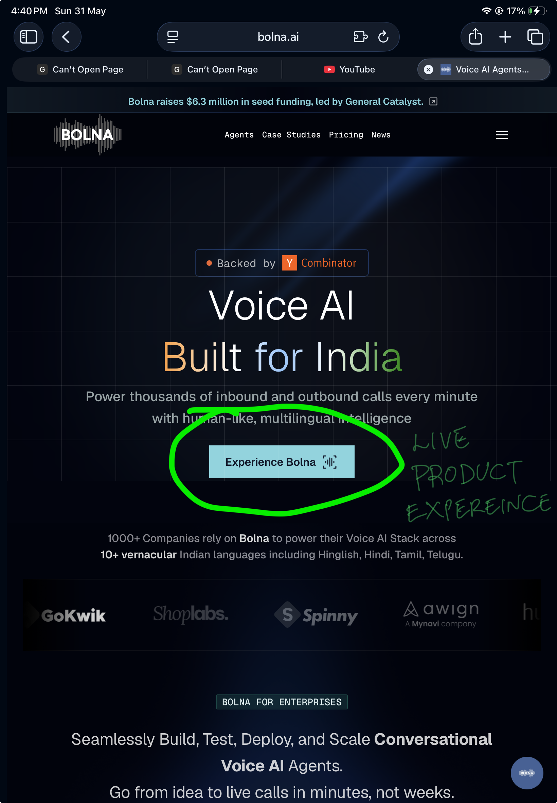
Bolna homepage — Experience Bolna live product CTA circled.
Figure 1: Bolna homepage. The “Experience Bolna” CTA lets buyers try a live voice interaction without any sales friction. Annotated: LIVE PRODUCT EXPERIENCE.

Bolna.ai — Outcome Examples with Real Agent Cards
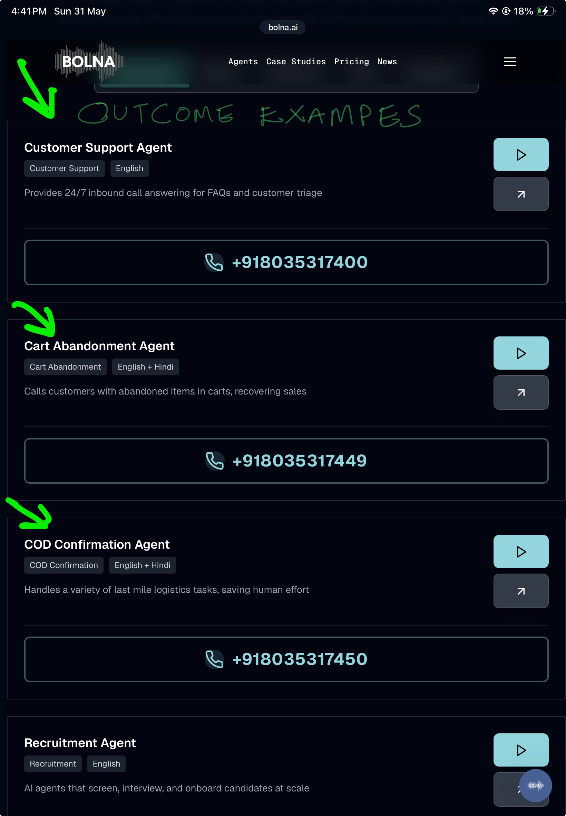
Bolna agents page showing Customer Support Agent, Cart Abandonment Agent, COD Confirmation Agent each with a play button and real phone number.
Figure 2: Bolna agents page. Each agent shows a concrete outcome label, language tags, and a callable phone number. Annotated: OUTCOME EXAMPLES.

Bolna.ai — Case Studies with Quantified Business Outcomes
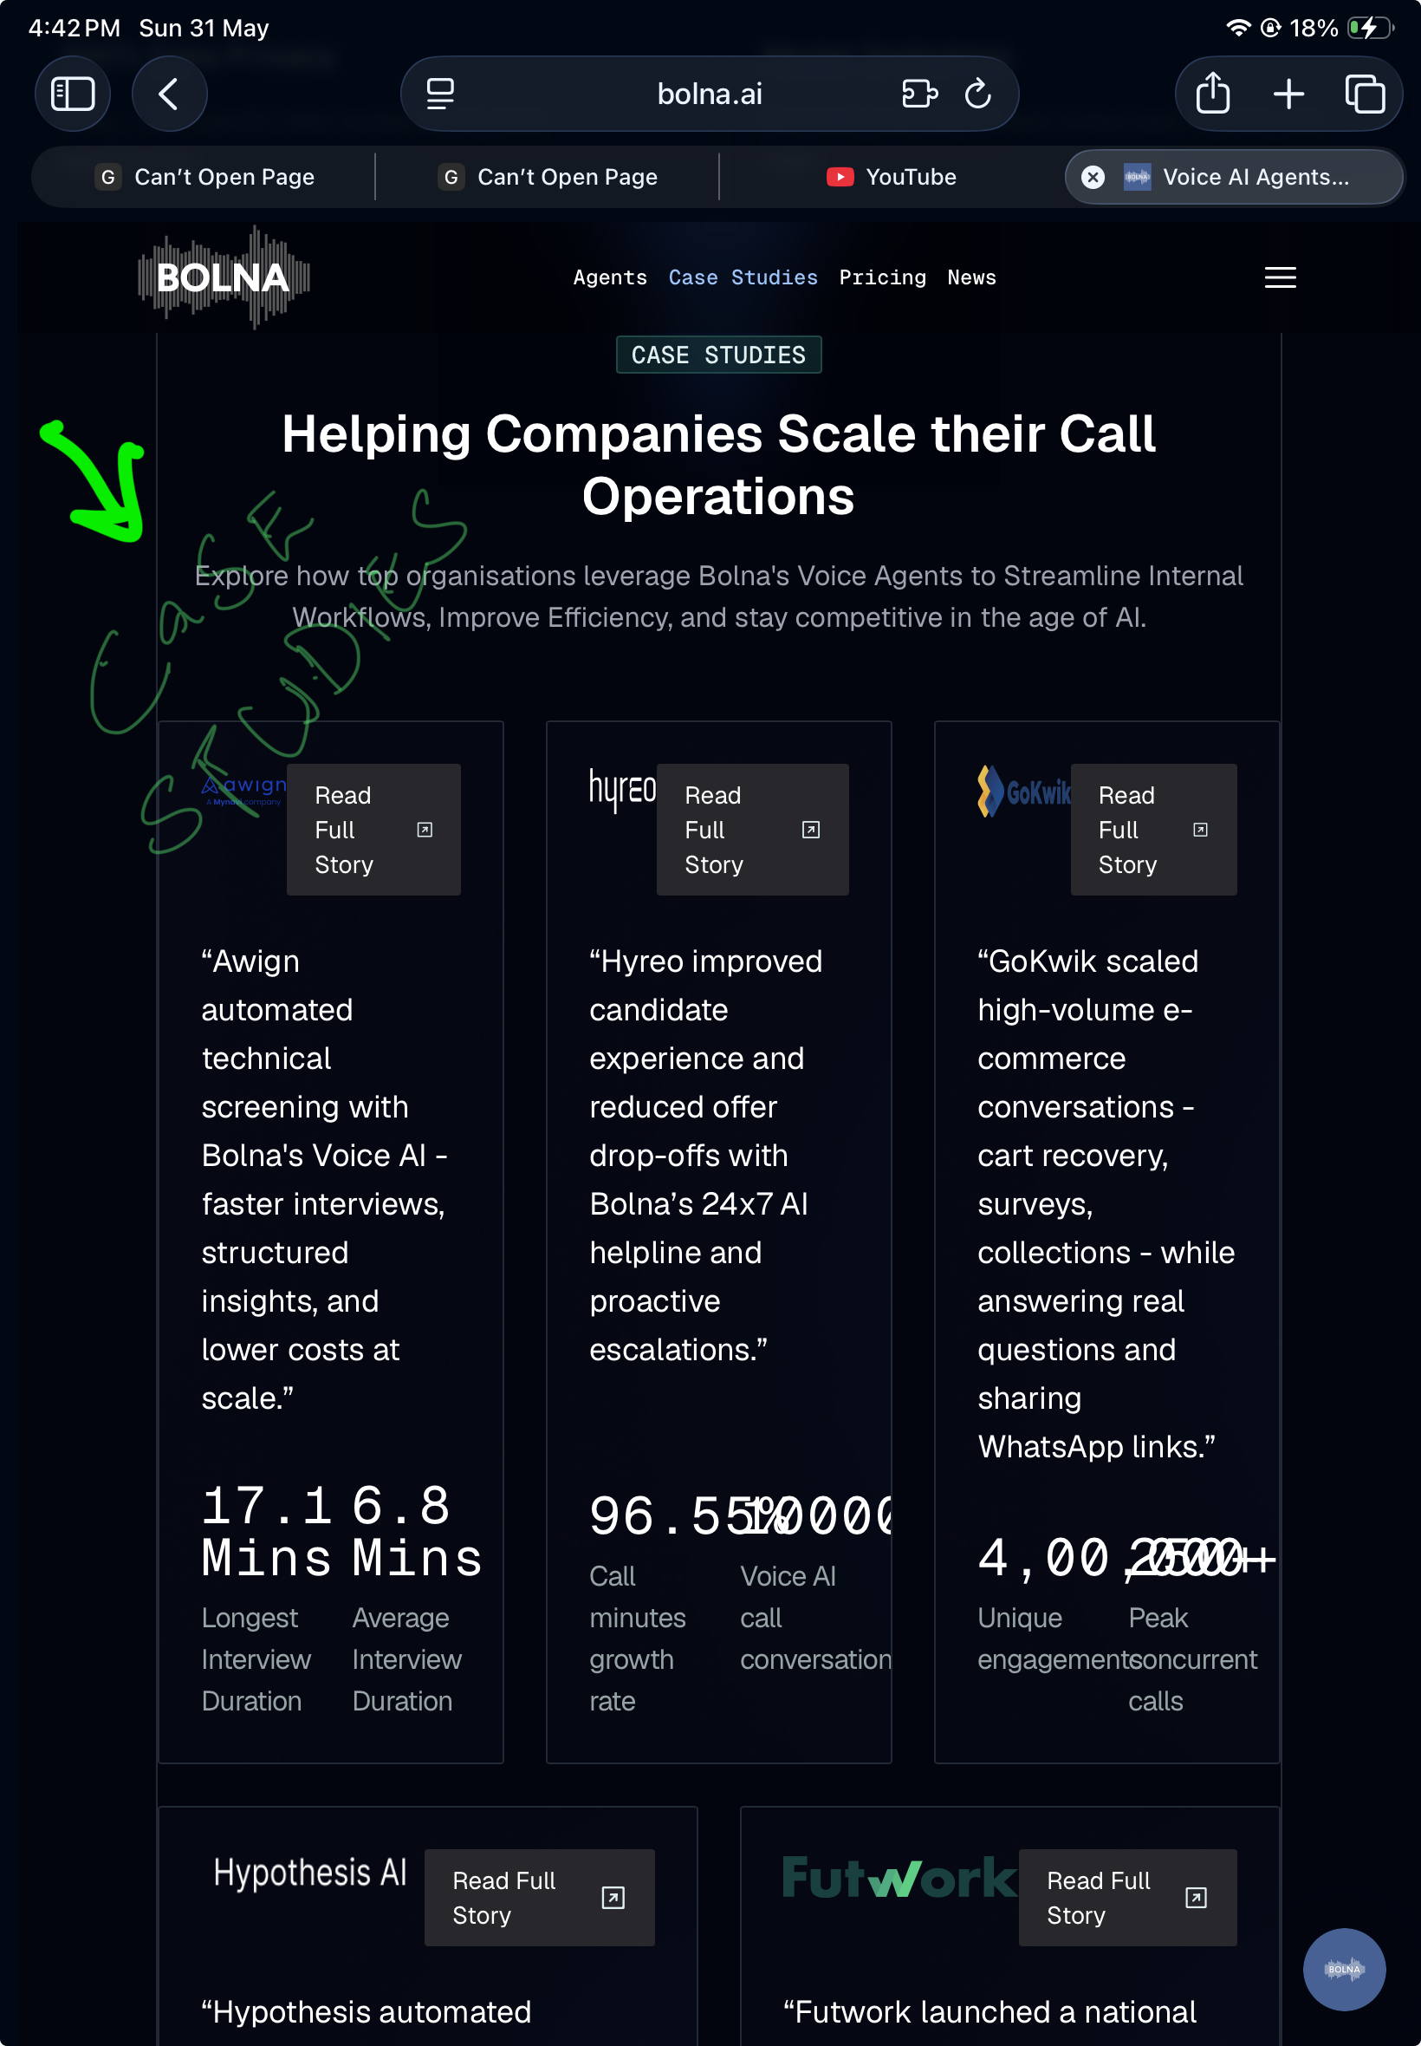
Bolna case studies page showing Awign, Hyreo, and GoKwik with specific metrics.
Figure 3: Bolna case studies. Each entry shows a customer quote and hard business metrics. Annotated: CASE STUDIES.

Retell.ai — Instant Live Call Without a Demo Form
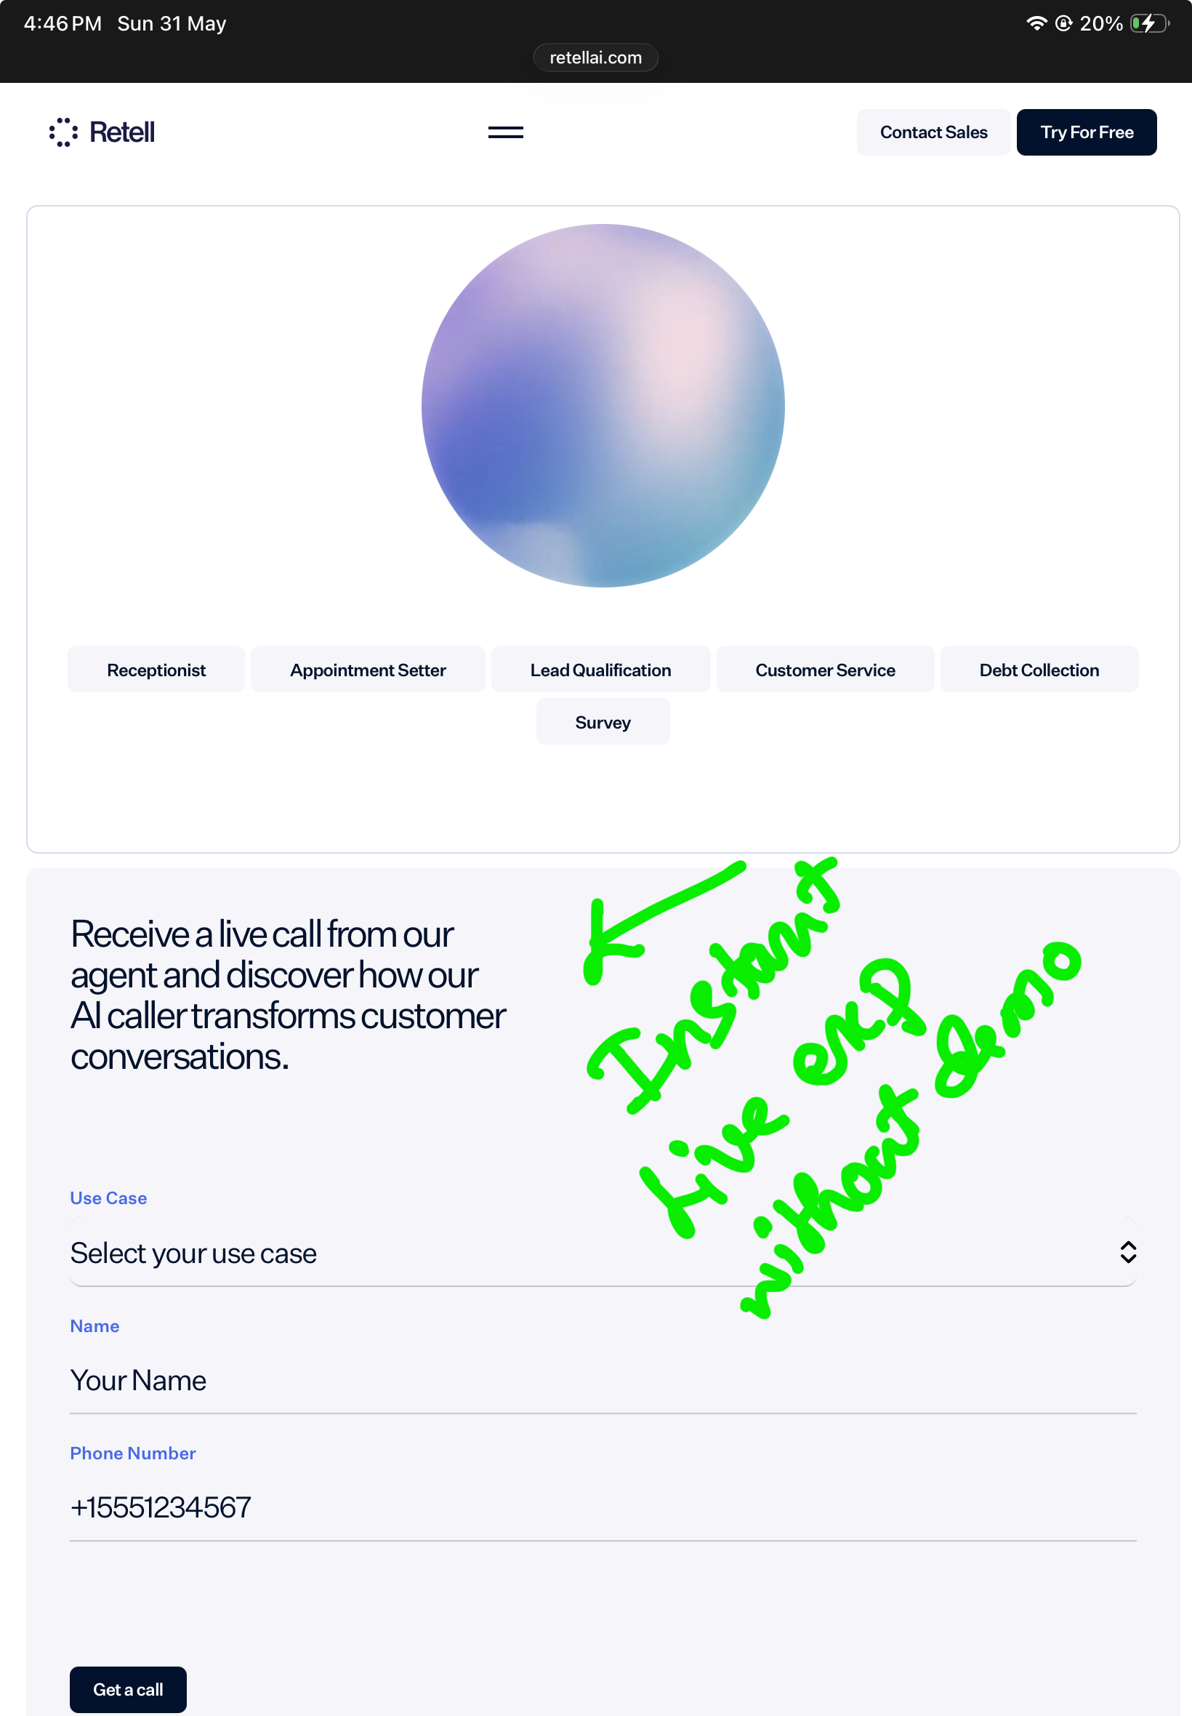
Retell homepage showing Receive a live call from our agent section with use case selector, name, and phone number.
Figure 4: Retell homepage. Visitors can receive a live AI call immediately — no demo booking required. Annotated: Instant live exp without demo.

Retell.ai — G2 Trust Signal Above the Fold
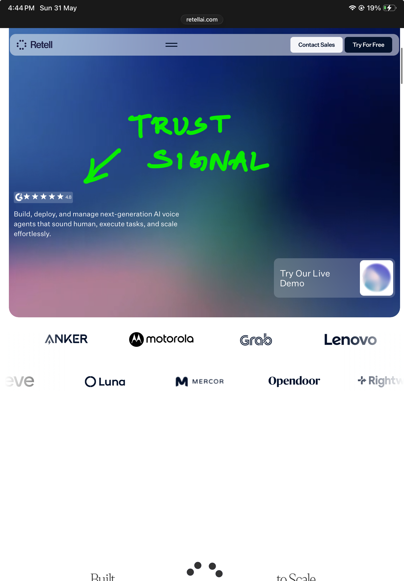
Retell homepage hero showing a G2 4.8-star rating prominently above the fold alongside a Try Our Live Demo CTA.
Figure 5: Retell homepage hero. G2 4.8-star rating appears as an anchor trust signal before any product description. Annotated: TRUST SIGNAL.

Vapi.ai — Live Voice Conversation Active on Homepage
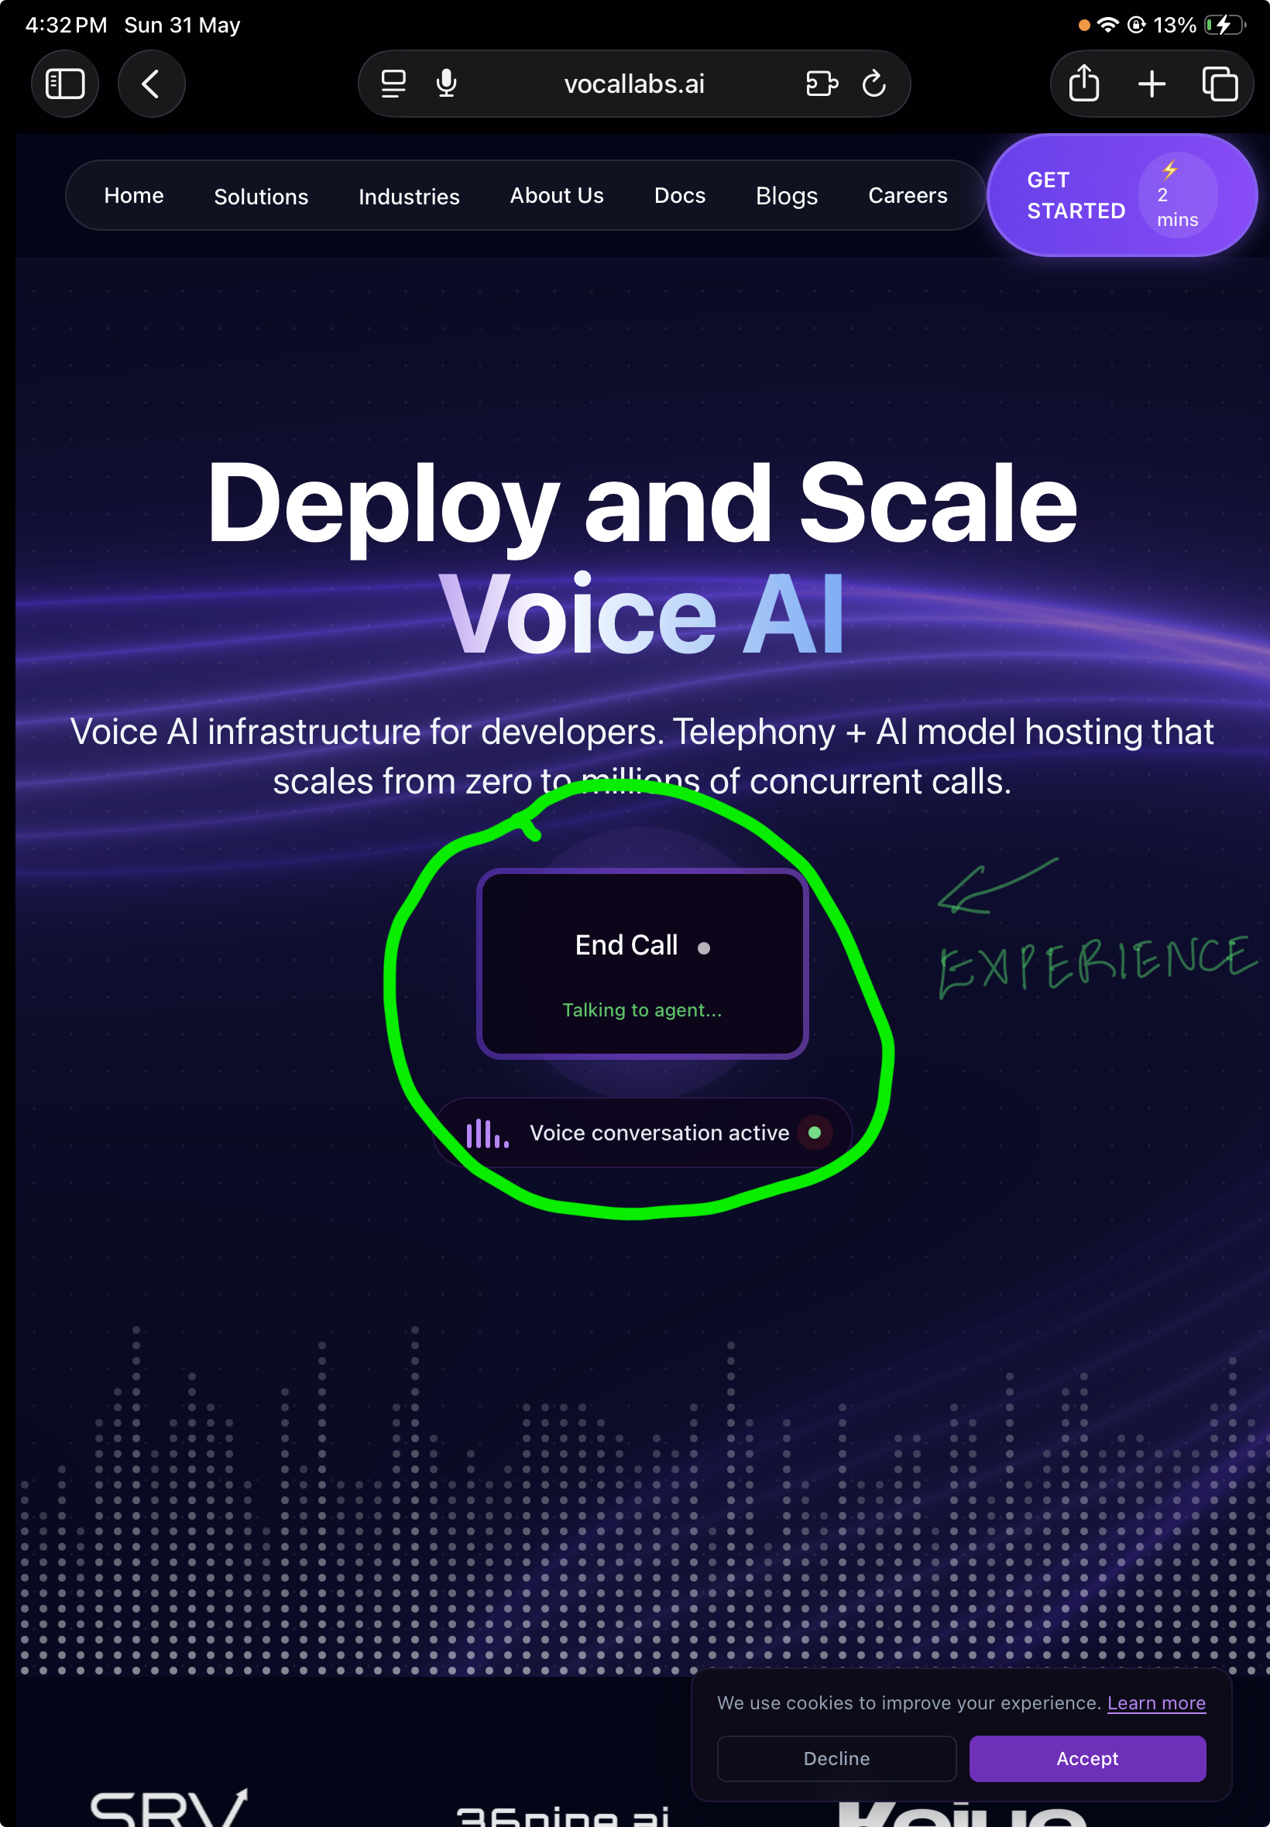
Vapi homepage showing End Call and Voice conversation active UI elements embedded directly in the hero.
Figure 6: Vapi homepage. A live voice conversation is active in the hero section — visitors experience the product before reading any copy. Annotated: EXPERIENCE.

Problem
In AI voice, trust is experiential. Buyers need to hear the agent, inspect the flow, understand tool actions, and see how failure or escalation works.
A website that only asks the buyer to schedule a demo delays proof. In a crowded category, this can make Vocallabs feel less concrete even if the actual product is strong.

Ship instead
Launch a Vocallabs Demo Library.

Demo Library v1
Demo | Scenario | What it proves | Placeholder
COD Confirmation Agent | Customer confirms/cancels COD order in Hinglish | India commerce readiness | [VIDEO PLACEHOLDER]
Delivery Reschedule Agent | Customer changes delivery slot after failed delivery | Operational automation | [VIDEO PLACEHOLDER]
Lead Qualification Agent | Agent captures budget, intent, timeline, and books follow-up | Sales ROI | [VIDEO PLACEHOLDER]
Appointment Booking Agent | Customer books or reschedules appointment | Structured service workflow | [VIDEO PLACEHOLDER]
FAQ + Escalation Agent | Customer asks confusing query; agent resolves or hands off | Safe automation | [VIDEO PLACEHOLDER]
Angry Customer Recovery | Customer complains; agent empathises and escalates correctly | Trust and CX | [VIDEO PLACEHOLDER]
Noisy Hinglish Call | Background noise, interruptions, mixed Hindi-English | India-scale robustness | [VIDEO PLACEHOLDER]

Demo page structure
Each demo page should include:
Section | Purpose
Video/audio | Let buyer experience the voice agent
Transcript | Make the flow inspectable
Call objective | Show what the agent was supposed to do
Tool actions | Show CRM/order/calendar/payment actions
Outcome status | Resolved, escalated, failed, follow-up needed
Escalation note | Show safety and handoff logic
VVRB mapping | Show which benchmark dimension this demo tests
CTA | “Try this call flow for your business”

Example demo card
## COD Confirmation Agent
**Use case:** E-commerce COD confirmation
**Language:** Hinglish
**Business objective:** Confirm order, reduce manual calling load
**Call outcome:** Resolved — customer confirmed delivery
**Tool actions:** Order status checked; confirmation updated in CRM; WhatsApp summary sent
**VVRB dimensions tested:** Resolution, Hindi/Hinglish robustness, tool completion, turn-taking
[DEMO VIDEO PLACEHOLDER]
[TRANSCRIPT PLACEHOLDER]
[OUTCOME CARD PLACEHOLDER]

Success metrics
Metric | Target direction
Demo library visits | Increase
Demo completion rate | Increase
Demo-to-meeting conversion | Increase
Self-serve try-call starts | Increase
Sales call quality | More informed prospects
Product objections captured | More structured roadmap input

Tradeoff
Public demos may expose imperfections. But this is healthy PM discipline. Each demo should become a benchmark scenario, and every exposed weakness should become a roadmap input.

Priority logic
RICE factor | Assessment
Reach | High — all prospective buyers
Impact | Very high — voice AI trust depends on hearing the product
Confidence | High — competitors expose demos more directly
Effort | Medium — demo production + page templates
Priority: P0

Feedback 3 — Features / Services

Turn call analytics into a resolution-and-ROI scorecard

Observed
Vocallabs’ docs show real operational depth: authentication, SIP/call APIs, call initiation, call details, call timeline, daily calls, audits, agents, analytics, dashboard, campaigns, marketplace, contacts, and groups.
This suggests the backend/product foundation exists to track call-level data. But the public product story does not yet translate this infrastructure into a clear customer-facing “what value did the AI create?” view.

Problem
Analytics alone is not enough. Customers need to know whether the AI created business value.
Customer question | Product metric needed
Did it solve the issue? | Autonomous resolution rate
Did it do the right action? | Tool/action completion
Did it escalate safely? | Correct escalation rate
Did it save time? | AHT saved
Did it reduce cost? | Estimated cost saved
Did it improve CX? | Sentiment recovery / CSAT proxy
Why did it fail? | Failure taxonomy
Without this layer, sales has to rely on subjective demo quality instead of measurable pilot outcomes.

Ship instead
Ship two artifacts:
- Pilot Scorecard v0
- Customer Outcomes Dashboard v0

A. Pilot Scorecard v0
Metric | Definition | Why it matters
Eligible calls | Calls AI is allowed to own | Avoids overclaiming
Autonomous resolution rate | % eligible calls resolved without human handoff | Core value metric
Correct escalation rate | % escalations made at the right time with context | Trust and safety
Tool/action completion | % calls where required business action was completed | Measures real work
AHT saved | Human minutes avoided | Cost savings
Abandonment/failure rate | Calls where user dropped or agent failed | Roadmap signal
Sentiment recovery | Negative → neutral/positive movement | CX signal
Estimated cost saved | Manual cost avoided | Buyer ROI

B. Customer Outcomes Dashboard v0
Internal signal | Customer-facing metric
EARP score | Autonomous resolution rate
Escalation correctness | Right-time handoff rate
Tool-call success | Completed CRM/order/calendar actions
Latency + turn-taking | Conversation smoothness
Sentiment recovery | CX recovery rate
Hallucination/safety failures | Compliance risk rate
Failure taxonomy | Top blockers to more automation

North Star metric
EARP — End-to-End Autonomous Resolution Parity: the percentage of eligible calls fully resolved by AI at human-or-better quality, with correct tool actions, safe behaviour, and customer-confirmed resolution.

Benchmark layer
VVRB — Vocallabs Voice Resolution Benchmark: a versioned benchmark that measures whether agents can resolve real-world calls across messy India-specific conditions.

Example Pilot Scorecard preview
Metric | Baseline | Pilot result | Change
Monthly eligible calls | 10,000 | 10,000 | —
AI autonomous resolution | 0% | 52% | +52 pts
Correct escalation | — | 91% | New
Avg human minutes avoided | — | 14,300 min | New
Estimated cost saved | — | ₹X/month | New
Top failure reason | — | Address ambiguity | Roadmap input

Success metrics
Metric | Target direction
% pilots with scorecard | 100%
Pilot-to-paid conversion | Increase
Top failure modes identified weekly | Increase initially, then reduce
EARP by use case | Improve
Correct escalation rate | Improve
Customer renewal / expansion intent | Improve

Tradeoff
This requires labeling discipline and may initially show lower automation rates than marketing wants. But it builds trust and identifies the exact roadmap blockers.

Priority logic
RICE factor | Assessment
Reach | Medium-high — pilots and enterprise customers
Impact | Very high — moves sales from demo claims to measurable ROI
Confidence | High — docs show call-level operational depth
Effort | Medium — dashboard/labeling/modeling work required
Priority: P1

Feedback 4 — UX

Reduce “time to proof” from demo-request friction to instant product experience

Observed
The website repeatedly pushes “Schedule Your Free Demo” and “see AI voice agents in action.” There is also a “Get Started” style CTA, but the public experience does not make it obvious that a buyer can immediately watch multiple demos, try a call, or inspect post-call outcomes.
The website should be audited for any trust leaks such as placeholder-looking copy, generic security claims, unpolished footer/header artifacts, or repeated CTA sections that make the product feel less concrete.

Observed: Logo Alignment Trust Leak in Google Search
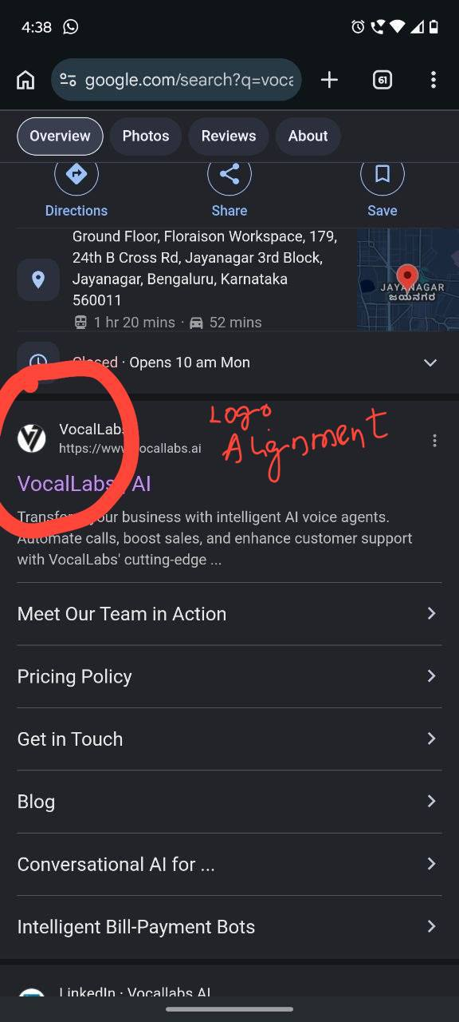
VocalLabs Google search result showing a misaligned logo in the Google business panel.
Figure 7: VocalLabs Google Search panel. The brand logo appears cropped and misaligned — a small but visible trust leak affecting first impressions before a buyer reaches the website. Annotated: Logo Alignment.

A useful contrast is Vocallabs’ own VocalFlow surface, which is more concrete: it has open-source positioning, product-specific setup flow, feature details, developer orientation, and clearer proof of what the tool does.

Problem
Voice AI needs fast trust.
A buyer should not need to book a meeting just to understand:
- what the agent sounds like,
- what use cases it handles,
- what actions it can take,
- how it behaves when the user interrupts,
- how it escalates to humans,
- what happens after the call,
- how success will be measured.
Small trust leaks matter more in enterprise AI because buyers are already worried about reliability, hallucinations, privacy, compliance, and customer experience.

Ship instead
Redesign the homepage around two paths.
Visitor | Primary CTA | Flow
Business buyer | Watch demos / Calculate ROI | Demo library → vertical page → pilot scorecard
Developer/operator | Build or test an agent | Docs quickstart → n8n/API template → sandbox call

Proposed hero copy
AI voice agents that resolve real customer calls, not just answer them.
Built for high-volume Indian business calls across support, sales, bookings, logistics, and follow-ups.
Watch demos · Try a call · Calculate ROI

Proposed navigation
Nav item | Destination
Demos | Demo library
Use Cases | Support, Sales, Logistics, Healthcare, Recruitment, E-commerce
Outcomes | ROI calculator, pilot scorecard, customer dashboard preview
Developers | API docs, SDK, n8n templates, Chrome extension
Benchmark | VVRB / Wild Calls Dataset explainer
Field Notes | Product learnings, call teardowns, benchmark notes
Contact | Book pilot / talk to sales

Homepage structure
- Hero: outcome-led headline and 3 CTAs
- Demo strip: 5–7 demo cards above the fold or immediately below
- Outcome proof: resolution rate, cost saved, escalation rate placeholders
- Use-case cards: e-commerce, logistics, healthcare, sales, recruitment
- How it works: design → call → act → analyze → improve
- Pilot scorecard preview: show how success will be measured
- Developer/operator section: docs, n8n, SDK, Chrome extension
- Trust/security section: clear named controls and data-handling details
- Field Notes: public learning channel
- Final CTA: Try a call / calculate ROI / run a 14-day pilot

Month-one UX changes
Area | Current gap | Change
Hero | Broad AI-agent positioning | Outcome-led headline around resolution
CTA | Demo request first | Add “Watch demos,” “Try a call,” “Calculate ROI”
Navigation | Broad pages | Use-case-first and proof-first IA
Proof | Limited public demos | Demo library above fold or in nav
Trust | Generic claims or artifacts | Clean brand assets + named security claims + trust center
Developer path | Docs exist but are not packaged as buyer proof | Add API/n8n quickstart and templates

Success metrics
Metric | Target direction
Time to first product proof | Decrease
Demo interaction rate | Increase
Try-a-call conversion | Increase
ROI calculator completions | Increase
Demo-to-sales conversion | Increase
Bounce rate on homepage | Decrease
Qualified demo requests | Increase

Tradeoff
Instant demos may reduce low-intent demo forms. But the sales calls that remain should be more informed, higher intent, and easier to convert.

Priority logic
RICE factor | Assessment
Reach | Very high — every website visitor
Impact | High — fastest trust and conversion improvement
Confidence | High — current funnel is demo-request-led
Effort | Medium-low — IA, copy, design, demo packaging
Priority: P0

Feedback 5 — Potential Collaborations

Turn SDK, n8n, Chrome extension, and open-source assets into a visible ecosystem

Observed
The assignment mentions SDK, n8n node, and Chrome extension as Vocallabs features. Public ecosystem signals also exist, including n8n integration and GitHub assets.
The n8n integration page positions VocalLabs as connectable with many apps and services. The GitHub n8n node describes VocalLabs as an AI Voice API node for automating voice calls, managing AI agents, and accessing call analytics.

Problem
These ecosystem assets are under-leveraged as GTM proof.
Buyers need to know whether Vocallabs fits their current stack:
- CRM
- telephony
- WhatsApp/SMS
- helpdesk
- calendar
- payments
- BI dashboards
- workflow automation tools
Developers and operators need templates, not just APIs.

Ship instead
Launch an Integration + Partner Proof Hub.
Category | What to show | Example template
n8n workflows | Ready automation templates | Missed call → AI callback → CRM update → WhatsApp follow-up
CRM/helpdesk | Workflow fit | Lead qualification → HubSpot/Zoho/Salesforce update
Telephony | Deployment confidence | Plivo/Twilio/SIP setup guides
WhatsApp/SMS | Post-call follow-up | Call summary → WhatsApp link/payment/confirmation
Calendar | Booking automation | Appointment call → calendar booking → reminder
Analytics/BI | Outcome reporting | Call outcomes → Sheets/Metabase/Looker dashboard
Indic AI stack | India-first technical credibility | Benchmark with Indic STT/TTS/language partners
Open-source | Developer trust | VocalFlow + SDK + sample eval datasets

Integration page template
## Missed Call → AI Callback → CRM Update → WhatsApp Follow-up
**Who this is for:** Sales and support teams handling high callback volume
**Trigger:** Missed call, form fill, or CRM lead status change
**Vocallabs action:** AI agent calls the customer, qualifies intent, resolves or escalates
**Post-call actions:** CRM updated, WhatsApp summary sent, human task created if needed
**Metrics tracked:** resolution, call outcome, sentiment, escalation, cost saved
[WORKFLOW DIAGRAM PLACEHOLDER]
[DEMO VIDEO PLACEHOLDER]
[N8N TEMPLATE LINK PLACEHOLDER]

Success metrics
Metric | Target direction
Integration hub visits | Increase
Template downloads / clones | Increase
Developer signups | Increase
n8n workflow activations | Increase
Sales objections around integration fit | Decrease
Pilot setup time | Decrease

Tradeoff
Partnership pages and templates require maintenance. Start with 5–7 high-value templates rather than a giant marketplace.

Priority logic
RICE factor | Assessment
Reach | Medium — strongest for operators/developers and enterprise buyers
Impact | High — reduces implementation anxiety
Confidence | Medium-high — ecosystem assets already exist
Effort | Medium — template and documentation work
Priority: P1

Strategic Layer — VVRB and Wild Calls Dataset

Why this matters
The website fixes are the low-hanging fruit, but the long-term moat should be measurement.
The same scenarios used in public demos should become benchmark cases. This prevents marketing and engineering from drifting apart.
Example:
If Vocallabs publishes a COD confirmation demo, VVRB should include harder variants.
Variant | Why it matters
Noisy background | Real Indian call environments
Hinglish | India-first language robustness
Customer interruption | Natural flow and barge-in handling
Angry customer | Empathy and escalation
Wrong address | Multi-step correction
CRM lookup failure | Tool failure recovery
Refund/cancellation request | Policy safety
Human handoff needed | Escalation correctness
A high VVRB score should mean the product is actually getting better at real customer calls, not just passing easy lab tests.

EARP: End-to-End Autonomous Resolution Parity

Definition
EARP is the percentage of eligible calls fully resolved by AI at human-or-better quality, with correct tool actions, safe behaviour, and customer-confirmed resolution.

What counts as resolved?
A call is resolved only if all required conditions are met:
Requirement | Meaning
User goal completed | The actual customer problem was solved
Customer confirmation | Customer understood and accepted the outcome
Correct business action | CRM/order/calendar/payment/ticket/timeline updated correctly
Safe behavior | No hallucinated promise, privacy issue, or policy violation
Escalation avoided only when appropriate | Agent did not hide uncertainty or block needed human help

EARP formula
EARP = Fully resolved eligible calls / Total eligible calls

Example
Total calls: 10,000
Eligible for AI: 6,000
Fully resolved by AI: 3,300
EARP = 3,300 / 6,000 = 55%

VVRB: Vocallabs Voice Resolution Benchmark

Purpose
VVRB should become the quality operating system for Vocallabs.
It should answer:
“Can this voice agent resolve messy real-world Indian business calls end-to-end?”

VVRB scoring dimensions
Dimension | What it tests
End-to-end resolution | Was the actual customer problem solved?
Customer confirmation | Did the customer understand and accept the outcome?
Tool/action completion | Did the agent correctly use CRM/order/calendar/payment/ticketing tools?
Correct escalation | Did it hand off at the right time with context?
Turn-taking | Did it handle interruptions, pauses, overlaps, and barge-ins?
India robustness | Accents, Hinglish, background noise, bad microphones
Multi-intent handling | Can one call contain order status + refund + address change?
Emotional intelligence | Angry, confused, anxious, impatient callers
Safety/compliance | No hallucinated refunds, false promises, or unsafe actions
Background action handling | Can it keep talking while checking systems or waiting for APIs?

Suggested VVRB weighting v0
Category | Weight
Resolution + task completion | 35%
Tool/action accuracy | 15%
Conversation flow + turn-taking | 15%
India robustness | 15%
Safety/compliance + escalation | 15%
Empathy/sentiment handling | 5%

Wild Calls Dataset v0

Dataset mix
Bucket | Share | Purpose
Real customer calls | 60% | Ground benchmark in actual user behaviour
Synthetic edge cases | 25% | Stress-test rare but important situations
Red-team/adversarial calls | 10% | Safety, fraud, policy, prompt injection, identity mismatch
Future interaction calls | 5% | Full-duplex, interruptions, background tool-use, long silences

Data principles
- Every production failure should become a labeled benchmark candidate.
- Every public demo should have harder hidden benchmark variants.
- Every benchmark failure should map to a product roadmap item.
- Every roadmap improvement should update both internal evals and customer-facing proof.
- Benchmark versions should be frozen, versioned, and comparable over time.

Example benchmark item
id: VVRB-COMMERCE-COD-001
use_case: COD confirmation
language: Hinglish
noise_level: medium
customer_state: impatient
business_goal: confirm order or cancel safely
required_tool_actions:
- fetch_order_status
- update_delivery_confirmation
- send_whatsapp_summary
expected_outcome: customer confirms delivery
failure_conditions:
- agent promises wrong delivery date
- agent fails to confirm intent
- agent ignores cancellation request
- agent fails to update CRM
- agent escalates unnecessarily
scoring_dimensions:
- resolution
- tool_completion
- turn_taking
- India_robustness
- safety

First-Month Execution Plan

Week 1 — Trust and funnel cleanup

Ship
Deliverable | Why
Full website audit with screenshots | Evidence-backed teardown and implementation clarity
Remove placeholder-looking brand/copy artifacts | Fast credibility win
Rewrite homepage hero around resolution | Better positioning
Add demo / ROI / docs / integrations navigation | Clearer user paths
Define demo scenarios and recording scripts | Prepares Demo Library

Output
Website no longer leaks trust; the product story becomes resolution-first.

Week 2 — Demo Library v1

Ship
Deliverable | Why
5–7 demo placeholders/videos | Fastest proof win
Demo transcript + outcome card | Makes demos inspectable
Tool action + escalation note | Shows real workflow depth
VVRB dimension tag | Connects demo to benchmark
Try-a-call flow | Reduces friction

Output
Buyers can experience Vocallabs before booking a sales meeting.

Week 3 — ICP pages + ROI calculator + Pilot Scorecard

Ship
Deliverable | Why
3 vertical outcome pages | Better ICP targeting
ROI calculator v0 | Business-case selling
Pilot Scorecard v0 | Measurable pilot success
Sales one-pagers per ICP | Faster GTM enablement

Output
Sales can move from feature demos to measurable business cases.

Week 4 — Field Notes + VVRB seed set

Ship
Deliverable | Why
Voice AI Field Notes channel | Public authority
First 2 posts | Demonstrates product thinking
VVRB v0 taxonomy | Quality operating system
Wild Calls Dataset seed: 100–200 scenarios | Future-proof benchmark foundation

Output
Public content, demo proof, evals, and product roadmap start feeding one another.

Website Revamp Appendix
This section can be copied directly into an AI website builder.

New homepage hero
# AI voice agents that resolve real customer calls, not just answer them.
Built for high-volume Indian business calls across support, sales, bookings, logistics, and follow-ups.
[Watch demos] [Try a call] [Calculate ROI]

Demo strip
## Hear Vocallabs in action
[COD Confirmation Demo Placeholder]
[Delivery Reschedule Demo Placeholder]
[Lead Qualification Demo Placeholder]
[Appointment Booking Demo Placeholder]
[Angry Customer Escalation Demo Placeholder]
[Noisy Hinglish Call Demo Placeholder]

Outcome proof section
## Measure what the AI actually resolved
Track autonomous resolution, correct escalation, tool completion, customer sentiment, and estimated cost saved across every pilot.
[Dashboard Screenshot Placeholder]
[Pilot Scorecard Placeholder]

Field Notes section
## Voice AI Field Notes
Real learnings from building voice agents for messy business calls.
- Why COD confirmation calls are harder than they look
- 5 ways voice agents fail in noisy Indian calls
- How to measure autonomous resolution, not just call completion
- What we learned from angry customer escalation calls

Demo Video Placeholder Scripts

Demo 1 — COD Confirmation Agent
Scenario: Customer receives a COD confirmation call in Hinglish.
Goal: Confirm order or cancel safely.
Must show: mixed language, order lookup, confirmation, WhatsApp follow-up.
Placeholder: [VIDEO PLACEHOLDER: COD Confirmation Agent]

Demo 2 — Delivery Reschedule Agent
Scenario: Delivery failed because the customer was unavailable.
Goal: Reschedule delivery and update logistics system.
Must show: address confirmation, slot selection, tool action.
Placeholder: [VIDEO PLACEHOLDER: Delivery Reschedule Agent]

Demo 3 — Lead Qualification Agent
Scenario: Inbound lead wants product/service details.
Goal: Capture budget, need, timeline, and book human follow-up.
Must show: qualification logic and CRM update.
Placeholder: [VIDEO PLACEHOLDER: Lead Qualification Agent]

Demo 4 — Appointment Booking Agent
Scenario: Patient/customer wants to book or reschedule an appointment.
Goal: Find slot, confirm, send reminder.
Must show: calendar action and confirmation.
Placeholder: [VIDEO PLACEHOLDER: Appointment Booking Agent]

Demo 5 — FAQ + Escalation Agent
Scenario: Customer asks a confusing support question.
Goal: Resolve FAQ if possible; escalate safely if needed.
Must show: clarifying questions and handoff threshold.
Placeholder: [VIDEO PLACEHOLDER: FAQ + Escalation Agent]

Demo 6 — Angry Customer Recovery
Scenario: Customer is frustrated about delay/refund/service issue.
Goal: Empathise, identify issue, avoid false promise, escalate with context.
Must show: sentiment recovery and safe handoff.
Placeholder: [VIDEO PLACEHOLDER: Angry Customer Recovery]

Demo 7 — Noisy Hinglish Call
Scenario: Background traffic/noise, interruptions, mixed Hindi-English.
Goal: Maintain flow and resolve the task.
Must show: India robustness and turn-taking.
Placeholder: [VIDEO PLACEHOLDER: Noisy Hinglish Call]

ROI Calculator v0

Inputs
Input | Description
Monthly call volume | Number of repetitive calls per month
Eligible call percentage | % of calls AI can safely handle
Current human cost per call | Fully loaded cost per call
Expected autonomous resolution rate | % eligible calls resolved by AI
AI cost per call | Vocallabs usage cost estimate
Average human minutes per call | Time saved when AI resolves

Formula
Eligible calls = Monthly call volume × Eligible call percentage
AI-resolved calls = Eligible calls × Autonomous resolution rate
Gross savings = AI-resolved calls × Human cost per call
AI cost = AI-resolved calls × AI cost per call
Net savings = Gross savings - AI cost
Human hours saved = AI-resolved calls × Average human minutes per call / 60

Output card
## Your estimated pilot impact
Eligible calls/month: [X]
Expected AI-resolved calls/month: [Y]
Human hours saved/month: [Z]
Estimated gross savings: [₹A]
Estimated net savings: [₹B]
Top metric to validate in pilot: Autonomous resolution rate
[Run a 14-day pilot]

Voice AI Field Notes Content Plan

Purpose
Create a public channel for product authority, not just SEO traffic.

Initial posts
Post | Purpose
Why COD confirmation calls are harder than they look | Shows domain insight
Introducing autonomous resolution as a metric | Establishes EARP thinking
How we test voice agents in noisy Indian calls | Supports India-first moat
What makes AI-to-human handoff trustworthy | Explains safety and hybrid model
Turning failed calls into product improvements | Shows product learning loop

Recommended format
Each Field Note should include:
- Problem observed
- Why it is hard
- Example call snippet/transcript
- What the product should do
- How Vocallabs measures success
- What improved after the change

Evidence / Screenshot Checklist
Attach screenshots or short clips for the final submission.
Evidence | Status | Why to attach
Current homepage hero and CTA | Shows observed GTM/UX issue
Blog page content list | Shows generic content channel issue
Contact/demo CTA flow | Shows demo-request friction
Docs navigation/API endpoints | Shows product depth exists underneath
VocalFlow page | Shows internal example of more concrete product page
Bolna homepage — Experience Bolna CTA | Attached (Figure 1) | Competitor live product experience benchmark
Bolna agents page — Outcome examples | Attached (Figure 2) | Competitor outcome-first proof benchmark
Bolna case studies — Business metrics | Attached (Figure 3) | Competitor quantified outcome proof
Retell — Instant live call without demo | Attached (Figure 4) | Competitor proof benchmark
Retell — G2 trust signal above fold | Attached (Figure 5) | Competitor trust benchmark
Vapi — Live demo active on homepage | Attached (Figure 6) | Competitor experience benchmark
VocalLabs logo alignment (Google search) | Attached (Figure 7) | Brand trust leak — UX observed evidence
Synthflow “Hear Demo” section | Pending | Competitor proof benchmark
n8n/GitHub integration page | Pending | Collaboration/ecosystem proof

Final Recommendation
Vocallabs should make the website:
Demo-first, outcome-first, and benchmark-backed.
The first-month focus should not be building a giant new feature. It should be reducing buyer friction and creating proof:
- Show real demos.
- Sell outcomes by vertical.
- Measure every pilot with a scorecard.
- Convert failed calls into benchmark scenarios.
- Use VVRB/EARP to guide product quality.
The durable PM loop:
Demos drive sales → sales exposes objections → objections become benchmark cases → benchmark failures become roadmap items → roadmap wins become stronger public proof.

References / Public Sources To Cite In Final Report
These are included as source links for the Markdown draft. Replace with screenshots where possible in the final submission.

Vocallabs
- Website: https://www.vocallabs.ai/
- Blog: https://vocallabs.ai/blogs
- API docs: https://docs.vocallabs.ai/vocallabs
- VocalFlow: https://vocallabs.ai/vocalflow
- n8n integration: https://n8n.io/integrations/vocallabs/
- GitHub n8n node: https://github.com/Vocallabsai/n8n-nodes-vocallabs

Competitors
- Bolna: https://www.bolna.ai/
- Retell: https://www.retellai.com/
- Synthflow: https://synthflow.ai/
- Vapi: https://vapi.ai/

Final Closing Line For The Assignment
If I joined Vocallabs, the product area I would want to own from Day 1 is the bridge between public proof, pilot outcomes, and product quality. I would start with the website and demo layer because it is the lowest-hanging fruit for trust and GTM conversion. Then I would connect every demo and pilot call into VVRB/EARP so that sales proof, customer dashboards, and engineering evals all compound into one product improvement loop.

